Bo Zhang :

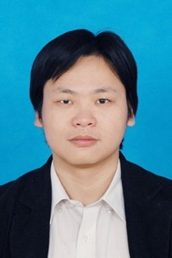

Guojian Zou:

Dongming Qin:

Yunjie Lu:

Yupeng Jin:

Hui Wang:

